Introduction

Fruit Ninja is a video game developed by Halfbrick. It was released April 21, 2010 for iPod Touch and iPhone devices, July 12, 2010 for the iPad, September 17, 2010 for Android OS devices. The game was well received by critics; in September 2010 sales exceeded three million downloads, four million in December 2010, and over 20 million across all platforms in March 2011. In May 2012, Fruit Ninja reached 300 million downloads. Reviewers felt that the low cost of the game combined with addictive gameplay yielded an excellent value. They further lauded the support and updates provided by Halfbrick, who brought online multiplayer, achievements, and leaderboards to the game.

In Fruit Ninja, the player slices fruit with a blade controlled via the touch screen. As the fruit is thrown onto the screen, the player swipes their finger across the screen to create a slicing motion, attempting to slice the fruit in half. Extra points are awarded for slicing multiple fruits with one swipe, and players can use additional fingers to make multiple slices simultaneously. Players must slice all fruit; if three fruits are missed, the game ends, but upon reaching scores that are multiples of one the player will gain an extra life unless they have not missed a piece of fruit already. Bombs are occasionally thrown onto the screen and will also end the game should the player slice them. Unless Bomb deflects are used.

Badges

Badges or Achievements are included within games to extend the game longevity and provide players with the thrill to do more than simply complete the game.

This game example is using Google play achievements. Which attached to google play account, so other player with google account can see your achievement earned and when you achieve itW from playing that game.  
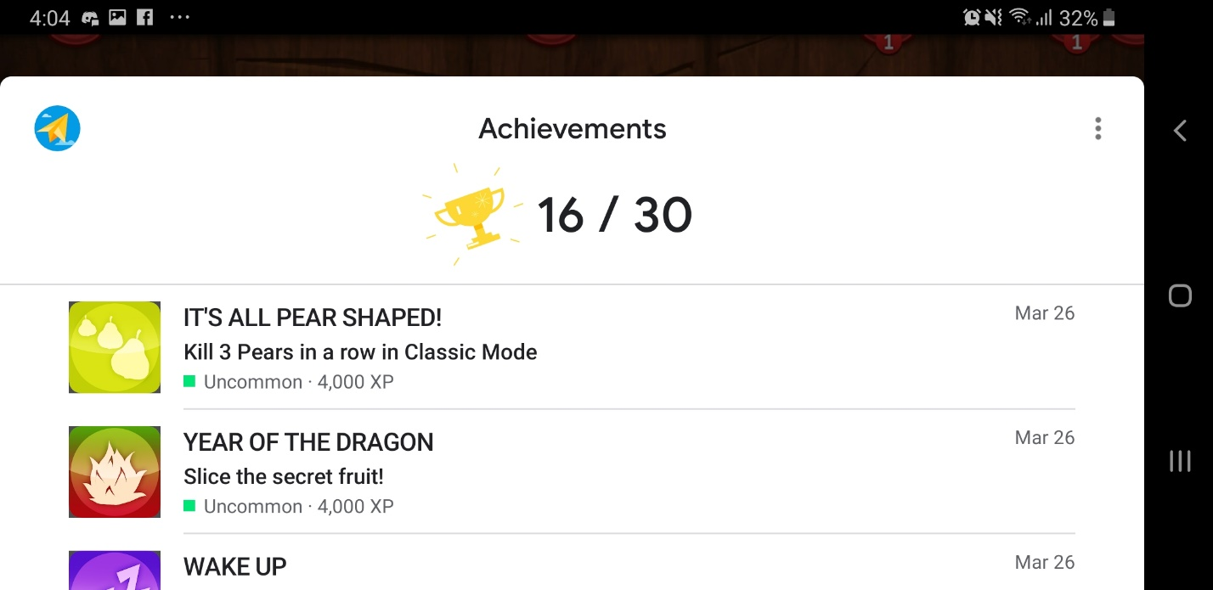  
  
They usually trivial achievement to do. However, some achievement are really specific and some are really difficult to get, so the developer can extend a lot of gameplay  
  
Example:  
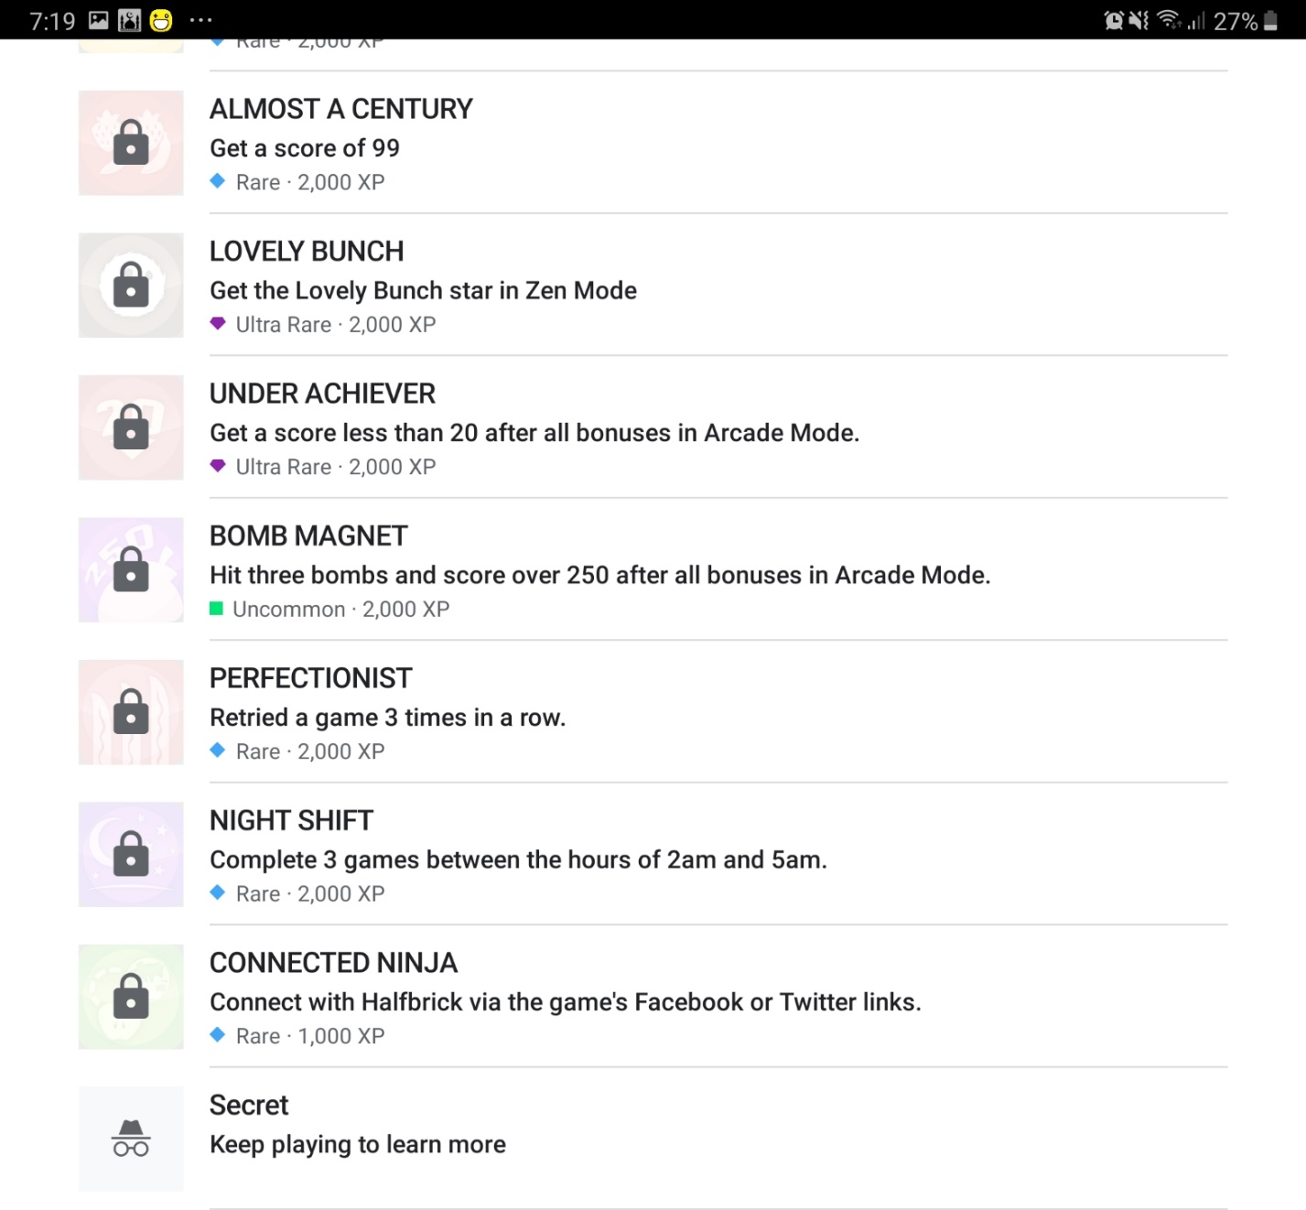  
some of these achievement are only be achieve if you read the achievement page.